**Exercise Numerical Modelling Module 1**

**Shiyi Li**

**Jiahui Kang 16-950-529**

1. **Cancellation**

Step 1 : 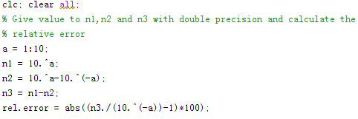

Step 2:

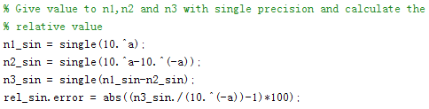

Step 3:

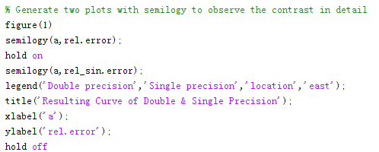

Result: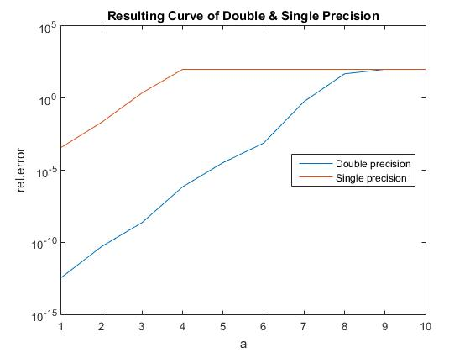

We can observe that calculation with double precision has smaller relative error than that with single precision at relatively small power and the difference reduces as the power increases.

1. **Numerical Differentiation**

Step 1:

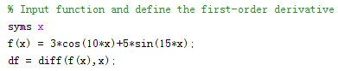

Step 2:

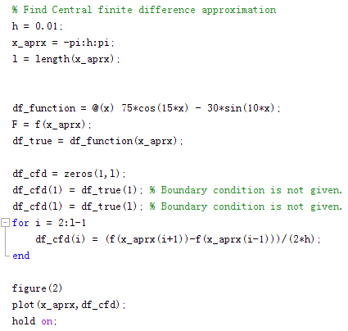

Step 3:

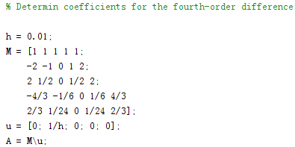

Step 4:

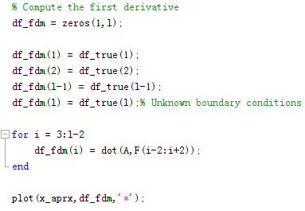

Result:

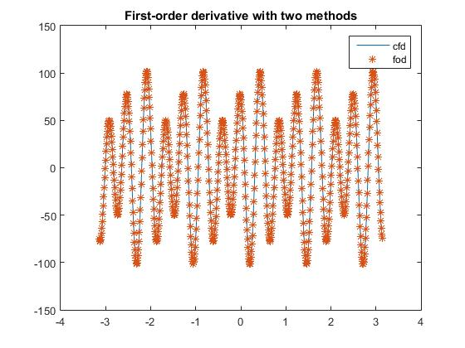

Step5:

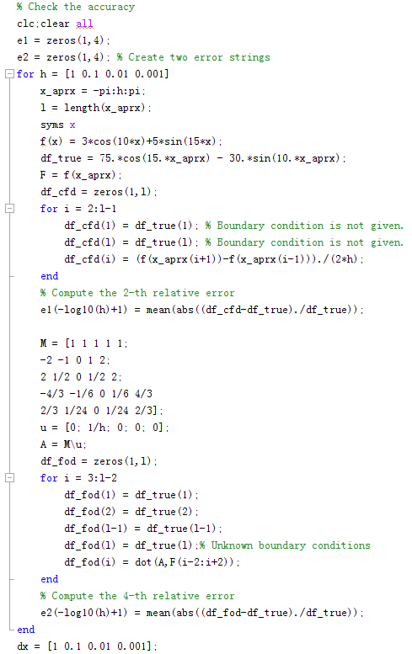

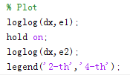

Result:

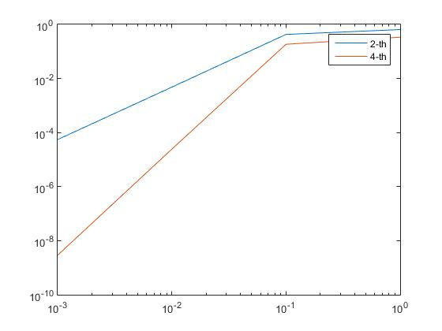

We can see from the figure that, 4-th order finite difference scheme gives smaller error than that of 2-nd order.

1. **Interpolation**

Step 1:

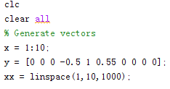

Step 2:

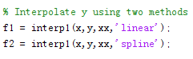

Step 3:

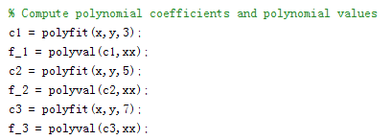

Step 4:

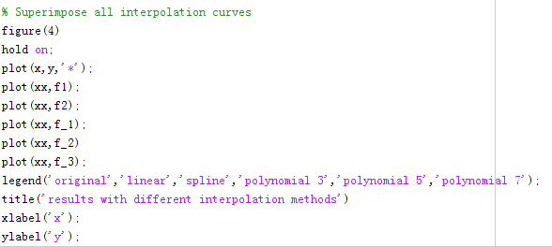

Result: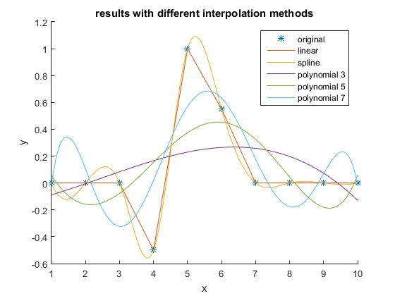

The result shows that the linear interpolation curve and the original curve totally overlap.

The spline interpolation gives smoother curve than the linear interpolation.

We compare three polynomial interpolation curves and we can see that higher degree gives us better fit.